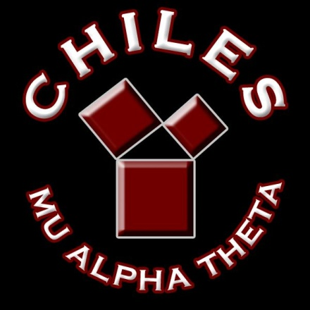**CHILES MU ALPHA THETA**

**2019-2020**

**COMPETITION SCHEDULE**

**TBA FSU Math Competition**

**November 16 Rickards Invitational**

**December 14 Chiles Mini Mu**

**January 11 Chiles Statewide**

**January 25 Buchholz Regional**

**February 1 Lincoln Regional**

**February 21-22 Palm Harbor Statewide**

**TBA NWFSC Math Bowl**

**March 7 Rickards Regional**

**April 23-26 State Convention @ Orlando**

**July 18-24 National Convention @**

**Myrtle Beach, SC**